[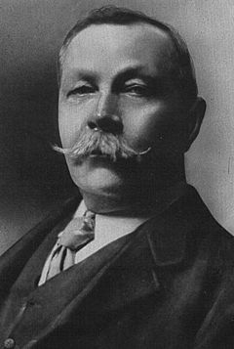](http://en.wikipedia.org/wiki/File:Conan_doyle.jpg)

Sir Arthur Conan Doyle

1859 – 1930

1. Where was he born?

2. Where was he educated?

3. Which profession did he follow?

4. When did he first start writing?

5. Where was his first medical practice and how successful was it?

6. Who was his most famous fictional creation?

7. When was he knighted and why?

8. Who did he marry?

9. Which popular Victorian religious movement was he interested in following the death of his son?

10. What was the name of his famous novel involving prehistoric creatures?

11. Which famous hoax did he appear to believe in?